|  |  |
| --- | --- |
| **Sprint 3** | **CREATING A FORM** |
| Team ID | PNT2022TMID17729 |
| Project Name | Project – Personal Assistance for Seniors Who Are Self-Reliant |

# NODE-RED DESIGN WITH FORM NODE:

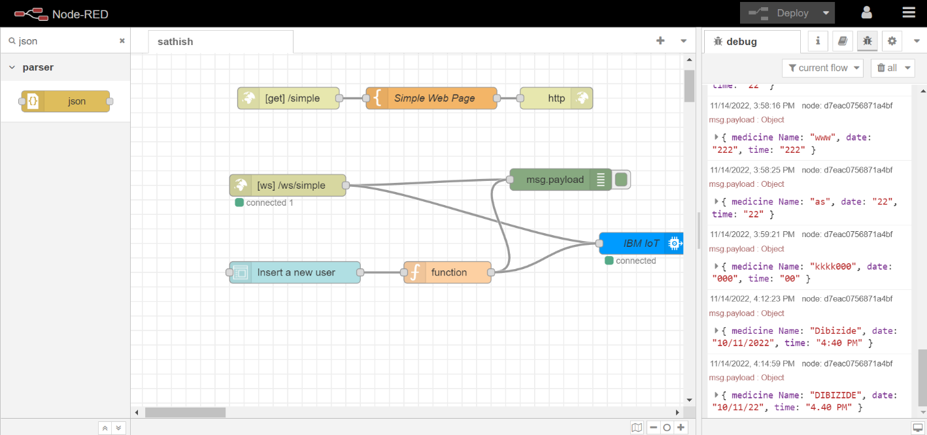

**FORM NODE:**

